**Experiment No.: 4**

**Integrate Software Components using middleware**

**Learning Objective:** Student should be able to integrate software components using middleware

**Tool:- Corba**

**Theory:**

Software system integration is essential where communication between different applications running on different platform is needed. Suppose a system designed for payroll running with Human Resource System. In that case employees’ data need to be inserted in both systems. The system integration benefits a lot in these cases where data and services needed to be shared.

Web services are becoming very popular to share data between systems over the network and over the internet as well. In software industry the software integration carried same steps as software development and hence demands same kind of development procedures and testing.

This ensures the meaningful and clear communication between the systems. Systems integration becomes inevitable in Enterprise Systems where the whole organization needed to share data and services and give the feel to user as one system. The core purpose of integration is to make the systems communicate and also to make the whole system flexible and expandable.

The integration of different softwares written in different language and based on different platforms can be tricky. In that situation a middleware is necessary to enable the communication between different softwares. The middleware enables the software system not only to share data but also share the services.

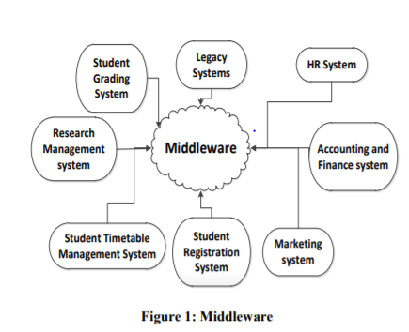

***A . Middleware***

Independently written software systems need to be integrated in large system for example industry, institution, etc. These systems need to agree on common method for integration. To get them communicate there is need to have something in between them. The middle thing is termed commonly as middleware.

***B .Service Oriented Architecture***

Service Oriented Architecture (SOA) is the architectural design and pattern which is used to provide services to different applications. Its goal is to achieve loose coupling between interacting components of applications. Web Services, Corba, Jini, etc are the technologies used to implement SOA.

Main benefit of SOA is that it can provide the means of communication between completely different applications (built in different technologies). The services are also completely independent and reusable and the nature of reusability provide the less time to market. All the services technologies needs to be implemented using the SOA design pattern and need to be designed on the basis of SOA to get maximum benefit.

***C .Web Services***

Web service is the SOA technology with additional requirements of using internet protocols (HTTP, FTP, SMTP, etc.) and using XML (Extensible Markup Language) for message transmission. [7] These are application components which communicate between different applications using open protocol. Open protocol is the web protocol for querying and updating information. These components can be used by different kinds of applications to exchange information. HTML (HyperText Markup Language) and XML are the basics of web service implementation.

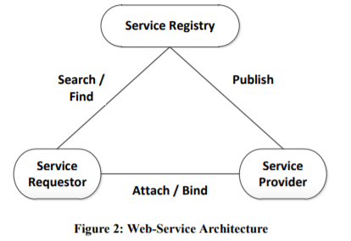

***D.WSDL (Web Service Descriptive Language)***

WSDL is a language to describe web services and providing the link to access these web services. It is acting as a publisher in web service architecture. It is the XML document which is recommended by W3C (World Wide Web Consortium) in 2007. In WSDL XML describes the service and the address from where applications can access the service. [8] WSDL predecessors were COM and CORBA

***E. UDDI (Universal Description, Discovery and Integration)***

It is directory service / registry service where applications can register and look for web services. It is Platform independent framework. It is acting like service register in web service architecture. It uses HTML, XML and DNS (Domain Name Server) protocols which enables it to become the directory service. It defines the keyword search, categories and classification for an application and registers it into business directory. In that way it is making the application easier to be approached by the customers online

***F. SOAP (Simple Object Access Protocol)***

It is a messaging / invoker in web service architecture. It is use to send messages in between the service and service consumer; and in between service consumer and service registry. It used to communicate with web service. It is a message framework which transfers the information between sender and receiver. SOAP doesn’t define the service but defines the mechanisms for messaging. It binds the client to the service

***G.SOA - A solution to spaghetti architecture***

In a fairly medium scale to large software architecture where there is need to integrate or communicate between different kinds of applications the introduction of links can make the architecture messy and it is called spaghetti architecture [9]. Figure 4 shows that problem in detail. It makes the system less flexible and expandability is the nightmare. Service Oriented Architecture (SOA) makes the architecture flexible and expandable.

**Result and Discussion:**

**Learning Outcomes:** Students should have be able to

LO1: Define Middleware.

LO2: Identify different components in middleware.

LO3: Explain Software Components using middleware.

.

**Course Outcomes:** Upon completion of the course students will be able to understand middleware and its components.

**Conclusion:**………………………………………………………………………………………

**Viva Questions:**

1. Define Middleware.
2. Explain Service Oriented Architecture.
3. Explain Web Services.
4. Explain Universal Description, Discovery and Integration.

For Faculty Use

|  |  |  |  |  |
| --- | --- | --- | --- | --- |
| **Correction Parameters** | **Formative Assessment [40%]** | **Timely completion of Practical [ 40%]** | **Attendance / Learning Attitude [20%]** |  |
|  |  |  |